#### **Data set :** [**https://sefiks.com/2018/08/27/a-step-by-step-cart-decision-tree-example/**](https://sefiks.com/2018/08/27/a-step-by-step-cart-decision-tree-example/)

There are 14 instances of golf playing decisions based on outlook, temperature, humidity and wind factors.

|  |  |  |  |  |  |
| --- | --- | --- | --- | --- | --- |
| **Day** | **Outlook** | **Temp.** | **Humidity** | **Wind** | **Decision** |
| 1 | Sunny | Hot | High | Weak | No |
| 2 | Sunny | Hot | High | Strong | No |
| 3 | Overcast | Hot | High | Weak | Yes |
| 4 | Rain | Mild | High | Weak | Yes |
| 5 | Rain | Cool | Normal | Weak | Yes |
| 6 | Rain | Cool | Normal | Strong | No |
| 7 | Overcast | Cool | Normal | Strong | Yes |
| 8 | Sunny | Mild | High | Weak | No |
| 9 | Sunny | Cool | Normal | Weak | Yes |
| 10 | Rain | Mild | Normal | Weak | Yes |
| 11 | Sunny | Mild | Normal | Strong | Yes |
| 12 | Overcast | Mild | High | Strong | Yes |
| 13 | Overcast | Hot | Normal | Weak | Yes |
| 14 | Rain | Mild | High | Strong | No |

**Gini index**

Gini index is a metric for classification tasks in CART. It stores sum of squared probabilities of each class. We can formulate it as illustrated below.

Gini = 1 – Σ (Pi)2 for i=1 to number of classes

**Outlook**

Outlook is a nominal feature. It can be sunny, overcast or rain. I will summarize the final decisions for outlook feature.

|  |  |  |  |
| --- | --- | --- | --- |
| Outlook | Yes | No | Number of instances |
| Sunny | 2 | 3 | 5 |
| Overcast | 4 | 0 | 4 |
| Rain | 3 | 2 | 5 |

Gini (Outlook=Sunny) = 1 – (2/5)2 – (3/5)2 = 1 – 0.16 – 0.36 = 0.48

Gini (Outlook=Overcast) = 1 – (4/4)2 – (0/4)2 = 0

Gini (Outlook=Rain) = 1 – (3/5)2 – (2/5)2 = 1 – 0.36 – 0.16 = 0.48

Then, we will calculate weighted sum of Gini indexes for outlook feature.

Gini (Outlook) = (5/14) x 0.48 + (4/14) x 0 + (5/14) x 0.48 = 0.171 + 0 + 0.171 = **0.342**

**Temperature**

Similarly, temperature is a nominal feature and it could have 3 different values: Cool, Hot and Mild. Let’s summarize decisions for temperature feature.

|  |  |  |  |
| --- | --- | --- | --- |
| Temperature | Yes | No | Number of instances |
| Hot | 2 | 2 | 4 |
| Cool | 3 | 1 | 4 |
| Mild | 4 | 2 | 6 |

Gini (Temp=Hot) = 1 – (2/4)2 – (2/4)2 = 0.5

Gini (Temp=Cool) = 1 – (3/4)2 – (1/4)2 = 1 – 0.5625 – 0.0625 = 0.375

Gini (Temp=Mild) = 1 – (4/6)2 – (2/6)2 = 1 – 0.444 – 0.111 = 0.445

We’ll calculate weighted sum of Gini index for temperature feature

Gini (Temp) = (4/14) x 0.5 + (4/14) x 0.375 + (6/14) x 0.445 = 0.142 + 0.107 + 0.190 = **0.439**

**Humidity**

Humidity is a binary class feature. It can be high or normal.

|  |  |  |  |
| --- | --- | --- | --- |
| Humidity | Yes | No | Number of instances |
| High | 3 | 4 | 7 |
| Normal | 6 | 1 | 7 |

Gini (Humidity=High) = 1 – (3/7)2 – (4/7)2 = 1 – 0.183 – 0.326 = 0.489

Gini (Humidity=Normal) = 1 – (6/7)2 – (1/7)2 = 1 – 0.734 – 0.02 = 0.244

Weighted sum for humidity feature will be calculated next

Gini (Humidity) = (7/14) x 0.489 + (7/14) x 0.244 = 0.367

**Wind**

Wind is a binary class similar to humidity. It can be weak and strong.

|  |  |  |  |
| --- | --- | --- | --- |
| Wind | Yes | No | Number of instances |
| Weak | 6 | 2 | 8 |
| Strong | 3 | 3 | 6 |

Gini (Wind=Weak) = 1 – (6/8)2 – (2/8)2 = 1 – 0.5625 – 0.062 = 0.375

Gini (Wind=Strong) = 1 – (3/6)2 – (3/6)2 = 1 – 0.25 – 0.25 = 0.5

Gini (Wind) = (8/14) x 0.375 + (6/14) x 0.5 = **0.428**

**Time to decide**

We’ve calculated Gini index values for each feature. The winner will be outlook feature because its cost is the lowest.

|  |  |
| --- | --- |
| Feature | Gini index |
| Outlook | **0.342** |
| Temperature | 0.439 |
| Humidity | 0.367 |
| Wind | 0.428 |

We’ll put outlook decision at the top of the tree.

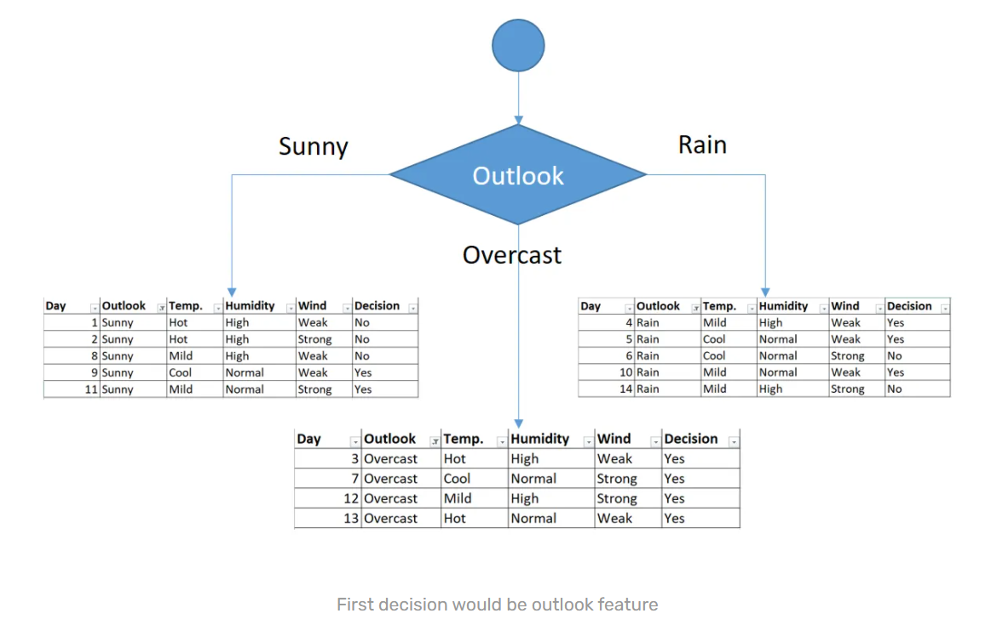

You might realize that sub dataset in the overcast leaf has only yes decisions. This means that overcast leaf is over.

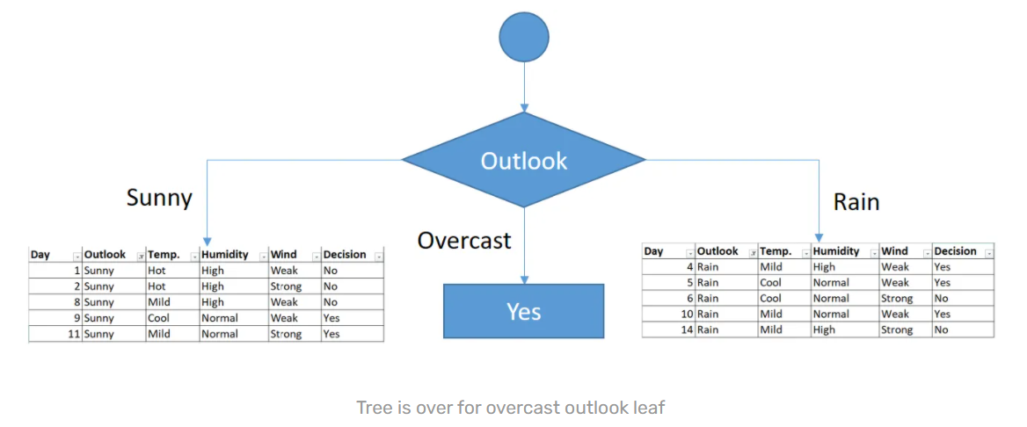

We will apply same principles to those sub datasets in the following steps.

Focus on the sub dataset for sunny outlook. We need to find the Gini index scores for temperature, humidity and wind features respectively.

|  |  |  |  |  |  |
| --- | --- | --- | --- | --- | --- |
| Day | Outlook | Temp. | Humidity | Wind | Decision |
| 1 | Sunny | Hot | High | Weak | No |
| 2 | Sunny | Hot | High | Strong | No |
| 8 | Sunny | Mild | High | Weak | No |
| 9 | Sunny | Cool | Normal | Weak | Yes |
| 11 | Sunny | Mild | Normal | Strong | Yes |

**Gini of temperature for sunny outlook**

|  |  |  |  |
| --- | --- | --- | --- |
| Temperature | Yes | No | Number of instances |
| Hot | 0 | 2 | 2 |
| Cool | 1 | 0 | 1 |
| Mild | 1 | 1 | 2 |

Gini (Outlook=Sunny and Temp.=Hot) = 1 – (0/2)2 – (2/2)2 = 0

Gini (Outlook=Sunny and Temp.=Cool) = 1 – (1/1)2 – (0/1)2 = 0

Gini (Outlook=Sunny and Temp.=Mild) = 1 – (1/2)2 – (1/2)2 = 1 – 0.25 – 0.25 = 0.5

Gini (Outlook=Sunny and Temp.) = (2/5)x0 + (1/5)x0 + (2/5)x0.5 = **0.2**

**Gini of humidity for sunny outlook**

|  |  |  |  |
| --- | --- | --- | --- |
| Humidity | Yes | No | Number of instances |
| High | 0 | 3 | 3 |
| Normal | 2 | 0 | 2 |

Gini (Outlook=Sunny and Humidity=High) = 1 – (0/3)2 – (3/3)2 = 0

Gini (Outlook=Sunny and Humidity=Normal) = 1 – (2/2)2 – (0/2)2 = 0

Gini (Outlook=Sunny and Humidity) = (3/5)x0 + (2/5)x0 = 0

**Gini of wind for sunny outlook**

|  |  |  |  |
| --- | --- | --- | --- |
| Wind | Yes | No | Number of instances |
| Weak | 1 | 2 | 3 |
| Strong | 1 | 1 | 2 |

Gini (Outlook=Sunny and Wind=Weak) = 1 – (1/3)2 – (2/3)2 = 0.266

Gini (Outlook=Sunny and Wind=Strong) = 1- (1/2)2 – (1/2)2 = 0.2

Gini (Outlook=Sunny and Wind) = (3/5)x0.266 + (2/5)x0.2 = 0.466

**Decision for sunny outlook**

We’ve calculated Gini index scores for feature when outlook is sunny. The winner is humidity because it has the lowest value.

|  |  |
| --- | --- |
| Feature | Gini index |
| Temperature | 0.2 |
| Humidity | 0 |
| Wind | 0.466 |

We’ll put humidity check at the extension of sunny outlook.

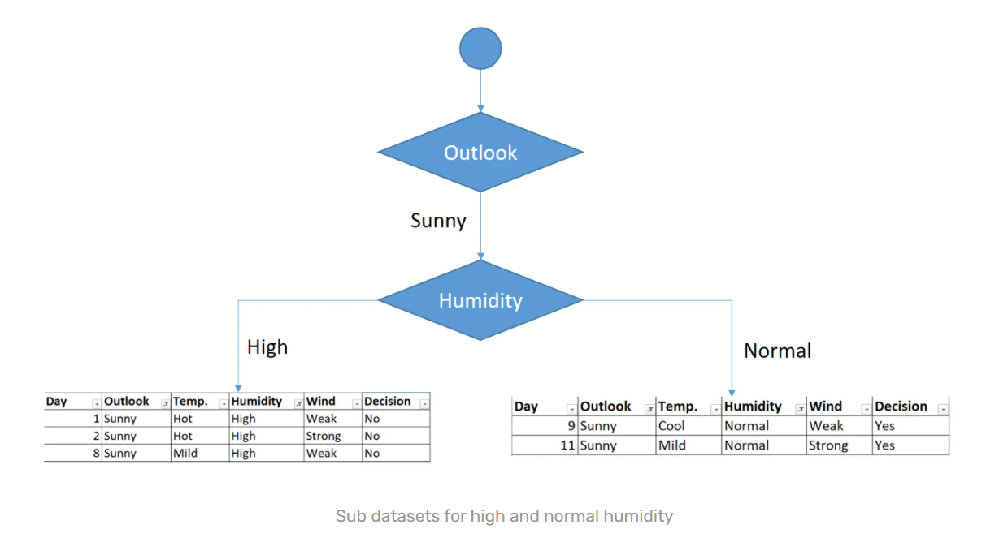

As seen, decision is always no for high humidity and sunny outlook. On the other hand, decision will always be yes for normal humidity and sunny outlook. This branch is over.

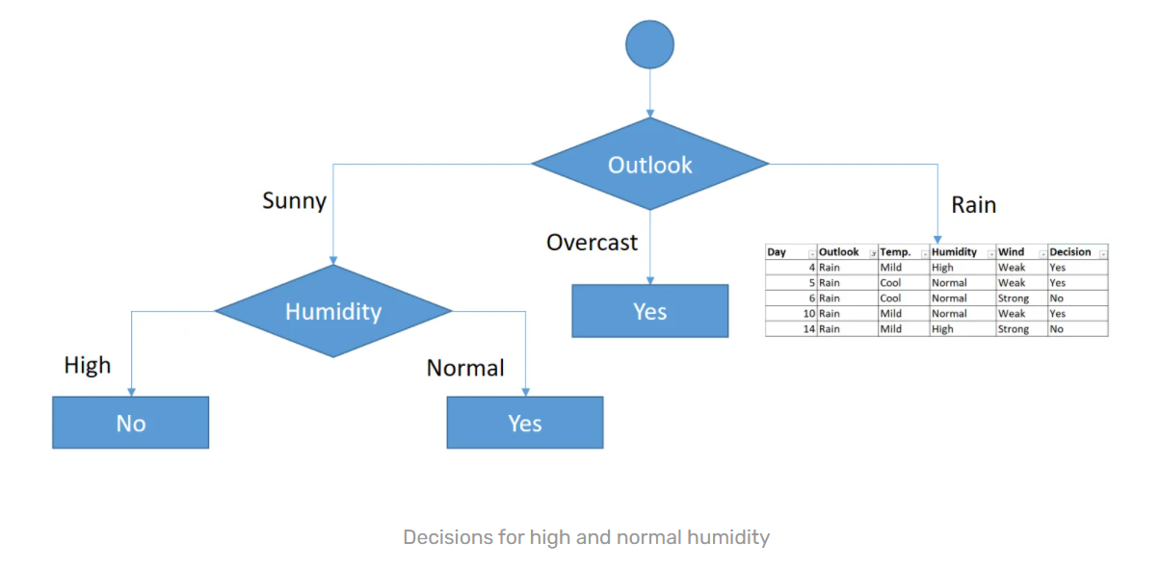

Now, we need to focus on rain outlook.

**Rain outlook**

|  |  |  |  |  |  |
| --- | --- | --- | --- | --- | --- |
| Day | Outlook | Temp. | Humidity | Wind | Decision |
| 4 | Rain | Mild | High | Weak | Yes |
| 5 | Rain | Cool | Normal | Weak | Yes |
| 6 | Rain | Cool | Normal | Strong | No |
| 10 | Rain | Mild | Normal | Weak | Yes |
| 14 | Rain | Mild | High | Strong | No |

We’ll calculate Gini index scores for temperature, humidity and wind features when outlook is rain.

**Gini of temperature for rain outlook**

|  |  |  |  |
| --- | --- | --- | --- |
| Temperature | Yes | No | Number of instances |
| Cool | 1 | 1 | 2 |
| Mild | 2 | 1 | 3 |

Gini (Outlook=Rain and Temp.=Cool) = 1 – (1/2)2 – (1/2)2 = 0.5

Gini (Outlook=Rain and Temp.=Mild) = 1 – (2/3)2 – (1/3)2 = 0.444

Gini (Outlook=Rain and Temp.) = (2/5)x0.5 + (3/5)x0.444 = 0.466

**Gini of humidity for rain outlook**

|  |  |  |  |
| --- | --- | --- | --- |
| Humidity | Yes | No | Number of instances |
| High | 1 | 1 | 2 |
| Normal | 2 | 1 | 3 |

Gini (Outlook=Rain and Humidity=High) = 1 – (1/2)2 – (1/2)2 = 0.5

Gini (Outlook=Rain and Humidity=Normal) = 1 – (2/3)2 – (1/3)2 = 0.444

Gini (Outlook=Rain and Humidity) = (2/5)x0.5 + (3/5)x0.444 = 0.466

**Gini of wind for rain outlook**

|  |  |  |  |
| --- | --- | --- | --- |
| Wind | Yes | No | Number of instances |
| Weak | 3 | 0 | 3 |
| Strong | 0 | 2 | 2 |

Gini (Outlook=Rain and Wind=Weak) = 1 – (3/3)2 – (0/3)2 = 0

Gini (Outlook=Rain and Wind=Strong) = 1 – (0/2)2 – (2/2)2 = 0

Gini (Outlook=Rain and Wind) = (3/5)x0 + (2/5)x0 = 0

**Decision for rain outlook**

The winner is wind feature for rain outlook because it has the minimum Gini index score in features.

|  |  |
| --- | --- |
| Feature | Gini index |
| Temperature | 0.466 |
| Humidity | 0.466 |
| Wind | 0 |

Put the wind feature for rain outlook branch and monitor the new sub data sets.

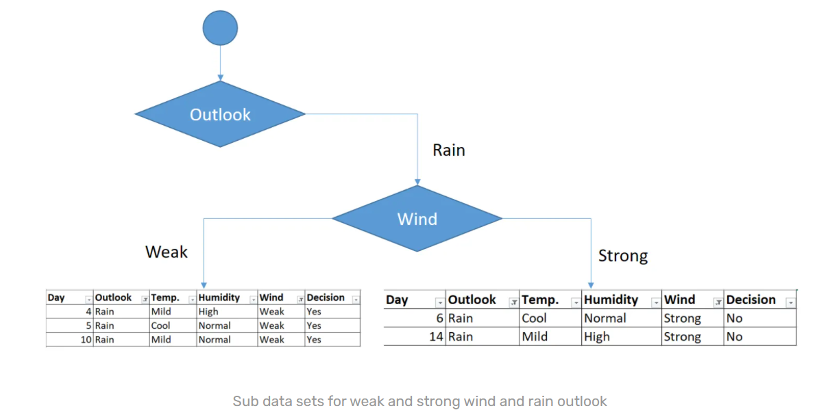

As seen, decision is always yes when wind is weak. On the other hand, decision is always no if wind is strong. This means that this branch is over.

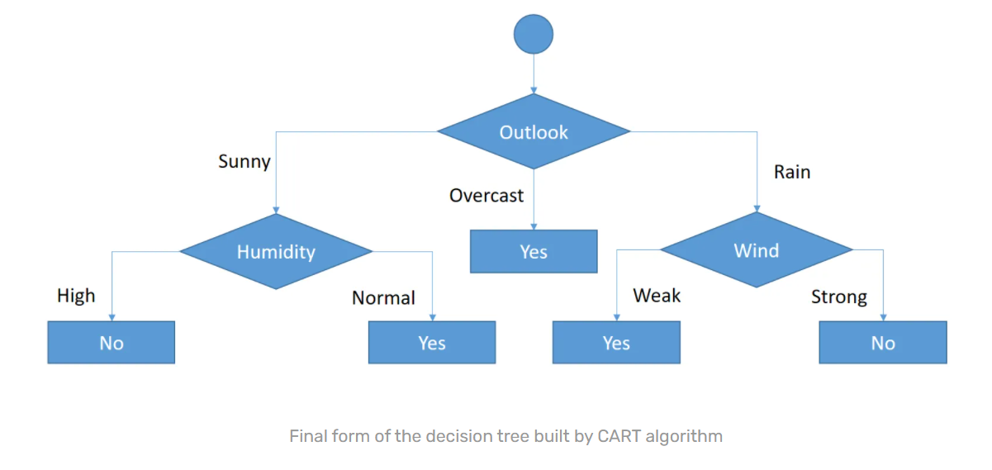

So, decision tree building is over. We have built a decision tree by hand. BTW, you might realize that we’ve created exactly the same tree in [ID3 example](https://sefiks.com/2017/11/20/a-step-by-step-id3-decision-tree-example/). This does not mean that ID3 and CART algorithms produce same trees always. We are just lucky. Finally, I believe that CART is easier than ID3 and C4.5, isn’t it?